**No table of figures entries found.**

Faculty of Engineering & Technology

Electrical and computer engineering department

ENEE 4113 Communication Laboratory

Delta Modulation (Linear &DCDM)

Report #1 Experiment#9

____________________________________________________________section: 1_______________

**Prepared by:**

Leyan Burait

**ID :**

1211439

**Partners:**

Rana Musa

**ID**

: 1210007

Hala Mohammed

**ID**

: 1210312

**Instructor:**

Dr. Ashraf Al-Rimawi

**Date: 20/4/2024**



# Abstract:

This experiment focuses on two types of Delta Modulation: Linear Delta Modulation (LDM) and Adaptive Delta Modulation (DCDM), examining how they recover input signals. Analog signals are encoded using LDM with two coding methods Return to Zero (RZ) and Non-Return to Zero (NRZ). The experiment also explores how Delta Modulation addresses issues such as granular noise and slope overload. Delta Modulation (DM) is a technique for converting analog signals into digital signals, valued for its simplicity and efficiency in digital communication systems. By studying both LDM and DCDM, the experiment aims to compare their modulation and demodulation processes in terms of signal quality and overall efficiency, So the primary goal of this experiment is to study and compare two types of delta modulation and demodulation techniques: Linear Delta Modulation (LDM) and Delta-Coded Delta Modulation (DCDM). This comparison will be used to evaluate and illustrate the power and performance characteristics of each modulation scheme, providing insights into their effectiveness and limitations.

________________________________________________________________________

**Page I**

Contents

Abstract: ب‌

*Table of figures: ح‌

Table of tables: خ‌

Theory**:** 1

1.Linear Delta Modulation (LDM): 1

Figure 1:Linear Delta Modulation [1] 1

1.1 Bit-rate [edit] 2

Figure 2:adabtive Delta Modulation [3] 2

1.3 Applications[edit] 3

Unipolar Return (RZ)and Non-return to zero(NRZ): 3

Figure 3:Unipolar Return and non-return to zero [5] 3

1.4 Slope Overload Distortion and Granular (Idle Noise), Quantization Noise in Delta Modulation 4

Slope Overload Distortion and Granular (Idle Noise) 4

1.4.1 Granular noise: 4

1.4.2Solution of the Granular Noise (Idle Noise) 4

1.4.2 Slope Overload Distortion 5

1.4.2.1Solution of Slope Overload Distortion 5

Figure 4:Granular and slope overload noises [7] 5

3Procedure 7

Part 1: Prediction signals in Linear delta modulation (LDM): 7

Figure 5: LDM block diagram [8] 7

Part 2: Prediction signals in Digital Controlled Delta Modulation (DCDM) : 8

Part 3: Pulse height in LDM: 8

8

Figure 6:Pulse height in LDM block diagram [8] 8

Part 4: Pulse height in DCDM: 9

Part 5: Output signals of the LDM modulator (RZ/NRZ): 9

9

Figure 7: LDM modulator (RZ/NRZ)block diagram 9

Part 6: Granular noise in LDM 9

10

Figure 8: Granular noise in LDM block diagram 10

Part 7: Granular noise in DCDM 10

Part 8: Slope-overload in LDM 11

Figure 9: Slope-overload in LDM block diagram 11

Part 9: Slope overload in DCDM 11

Part 10: Dynamic of LDM and DCDM 11

10.1 Dynamic of LDM 11

12

Figure10: Dynamic of LDM and DCDM 12

10.2 Dynamic of DCDM 12

2. Results and Discussion 12

Part 1: Prediction signals in Linear delta modulation (LDM): 12

Figure11: Set the Clock frequency fClock = 100 kHz (max) 13

Figure12: Set the function generator to: Sine, fm = 100 Hz, VSS = 1 V 13

4.1.1result of part 1 in time domain 13

Figure 13:LDM modulated signal when Fclk=100KHz in time domain 15

In this figure the clock freq was the max (100KHz) and the black wave represent the original signal and the red one is the predicted .The figure below show the signal when the clock freq was reduced to the min value (10KHz): 15

Figure 14:LDM modulated signal when Fclk=10KHz 15

Part 2: Prediction signals in Digital Controlled Delta Modulation (DCDM) : 16

Figure15: DCDM modulated signal at max fclk 16

Figure 16: DCDM modulated signal at min fclk 17

Part 5: Output signals of the LDM modulator (RZ/NRZ): 17

18

Figure 17: Output signals of the LDM modulator (RZ/NRZ) 18

Part 6: Granular noise in LDM: 18

19

Figure 18: Granular noise in LDM at the input of ∫2 , when fm=10k 19

Figure 19: Granular noise in LDM at the input of ∫2 , when fm=100k 19

Figure 20: Granular noise in LDM when bridging plug removed at fm=10khz 19

Figure 21: Granular noise in LDM when bridging plug removed at fm=100khz 20

Part 7: Granular noise in DCDM: 20

Figure 22: Granular noise inDCDM fm=10khz 21

Figure 23: Granular noise inDCDM fm=100khz 21

Part 8: Slope overload in LDM: 21

24: Slope overload in LDM when function genarator is sin 22

Figure 25: Slope-overload in LDM when function genarator is pulse with fm=100hz 22

Figure 26: Slope-overload in LDM when function genarator is pulse with fm=300hz 23

Part 9: Slope overload in DCDM: 24

Figure 27: Slope overload in DCDM when function generator is sin 25

Figure 28: Slope-overload in DCDM when function generator is pulse with fm=100hz 26

Figure 29: Slope-overload in DCDM when function generator is pulse with fm=300hz 26

Part 10: Dynamic of LDM and DCDM: 27

Figure 30:Dynamic of LDM and DCDM with fm=100hz and Vss=1v 27

Figure 31:Dynamic of LDM and DCDM with fm=100hz and Vss=2.9(max) 28

Table 1. Dynamic of LDM 28

500 29

Table 2. Dynamic of DCDM 29

Part 11: 30

Demodulation (LDM/DCDM): 30

.Demodulation for LDM 30

Figure 32:LDM Demodulation when sine generator with fm=100hz 30

Figure 33:LDM Demodulation when pulse generator with fm=100hz 31

Figure34LDM Demodulation when pulse generator with fm=300hz 31

.Demodulation for 32

DCDM 32

Figure 35:DCMD Demodulation when sine generator with 32

fm=100hz 32

Figure 36:DCMD Demodulation when pulse generator with fm=100hz 32

Conclusion: 33

Refrences: 34

## 

### *Table of figures:

Figure 1:Linear Delta Modulation [1] ...............................................................................................................0

Figure 2:adabtive Delta Modulation [3] ............................................................................................................... 1

Figure 3:Unipolar Return and non-return to zero [5] ...............................................................................................2

Figure 4:Granular and slope-overload noises [7] ......................................................................................................4

Figure 5: Figure 5: LDM block diagram [8].............................................................................................................6

Figure 6: Pulse height in LDM block diagram [8] ............................................................................................... 7

Figure 7: LDM modulator (RZ/NRZ)block diagram [8]……………………………………………………….8

Figure 8: Granular noise in LDM block diagram …………………………………………………………………9

Figure 9: Slope-overload in LDM block diagram …………………………………………………………………10

Figure10: Dynamic of LDM and DCDM……………………………………………………….11

Figure 11:LDM modulated signal when Fclk=100KHz ...........................................................................................12

Figure 12:LDM modulated signal when Fclk=10KHz ........................................................................................... 13

Figure 13: LDM modulator (RZ/NRZ)block diagram ........................................................................................... 13

Figure 14:LDM modulated signal when Fclk=10KHz ........................................................................................... 14

Figure15: DCDM modulated signal at max fclk........................................................................................... ……….15

Figure16: DCDM modulated signal at min fclk.......................................................................................................... 15

Figure 17: Output signals of the LDM modulator (RZ/NRZ)…………………………………………………………………………16

Figure 18: Granular noise in LDM at the input of ∫2 , when fm=10k…………………………………………..17

Figure 19: Granular noise in LDM at the input of ∫2 , when fm=100k…………………………………………..17

Figure 20: Granular noise in LDM when bridging plug removed at fm=10khz **…………………………………18**

Figure 21: Granular noise in LDM when bridging plug removed at fm=100khz………………………………….19

Figure 22: Granular noise inDCDM fm=10khz………………………………………………………………….20

Figure 23: Granular noise inDCDM fm=100khz………………………………….…………………………….21

24: Slope overload in LDM when function generators is sin ……………………………………………………….22

Figure 25: Slope-overload in LDM when function genarator is pulse with fm=100hz……………………………23

Figure 26: Slope-overload in LDM when function genarator is pulse with fm=300hz ……………………23

Figure 27: Slope overload in DCDM when function generator is sin …………………………………………24

Figure 28: Slope-overload in DCDM when function generator is pulse with fm=100hz………………………….25

Figure 29: Slope-overload in DCDM when function generator is pulse with fm=300hz……………………26

Figure 30:Dynamic of LDM and DCDM with fm=100hz and Vss=1v**………………………………26**

Figure 31:Dynamic of LDM and DCDM with fm=100hz and Vss=2.9(max)…………………………………..27 Figure 32:LDM Demodulation when sine generator with fm=100hz

Figure 33:LDM Demodulation when pulse generator with fm=100hz

Figure 34:LDM Demodulation when pulse generator with fm=300hz

Figure 35:DCMD Demodulation when pulse generator with fm=100hz

### Table of tables:

Table 1. Dynamic of LDM.........................................................................................................27

Table 2. Dynamic of DCDM.......................................................................................................28

## Theory**:**

### 1.Linear Delta Modulation (LDM):

Delta modulation (DM or Δ-modulation) is an [analog-to-digital](https://en.wikipedia.org/wiki/Analog-to-digital_converter) and [digital-to-analog signal](https://en.wikipedia.org/wiki/Digital-to-analog_converter) conversion technique used for transmission of voice information where quality is not of primary importance. DM is the simplest form of [differential pulse-code modulation](https://en.wikipedia.org/wiki/Differential_pulse-code_modulation) (DPCM) where the difference between successive samples is encoded into n-bit data streams. In delta modulation, the transmitted data are reduced to a 1-bit data stream representing either up (↗) or down (↘). Its main features are[1]:

* The analog signal is approximated with a series of segments.
* Each segment of the approximated signal is compared to the preceding bits and the successive bits are determined by this comparison.
* Only the change of [information](https://en.wikipedia.org/wiki/Information) is sent, that is, only an increase or decrease of the signal amplitude from the previous sample is sent whereas a no-change condition causes the modulated signal to remain at the same ↗ or ↘ state of the previous sample..[1]

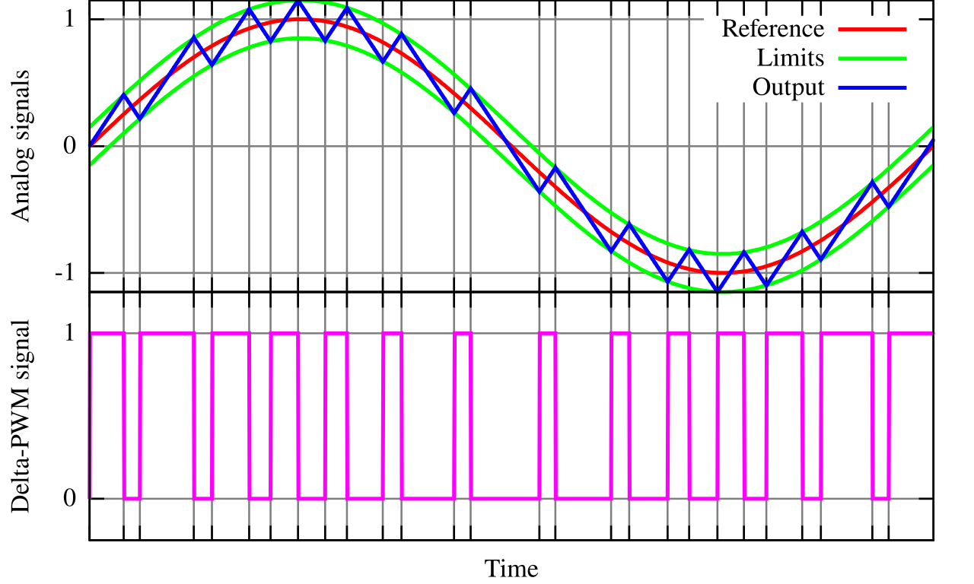

### Figure 1:Linear Delta Modulation [1]

### 1.1 Bit-rate [[edit](https://en.wikipedia.org/w/index.php?title=Delta_modulation&action=edit&section=4)]

If the communication channel is of limited bandwidth, there is the possibility of interference in either DM or [PCM](https://en.wikipedia.org/wiki/Pulse-code_modulation). Hence, 'DM' and 'PCM' operate at same bit-rate which is equal to N times the sampling frequency[1].[[*dubious*](https://en.wikipedia.org/wiki/Wikipedia:Accuracy_dispute#Disputed_statement)*–*[*discuss*](https://en.wikipedia.org/wiki/Talk:Delta_modulation#Dubious)]

**1.2. Adaptive Delta Modulation (DCDM).:**

Adaptive delta modulation (ADM) was first published by Dr. John E. Abate ([Bell Labs](https://en.wikipedia.org/wiki/Bell_Labs) Fellow) in his doctoral thesis at [NJ Institute Of Technology](https://en.wikipedia.org/wiki/New_Jersey_Institute_of_Technology) in 1968.[[7]](https://en.wikipedia.org/wiki/Delta_modulation#cite_note-7) ADM was later selected as the standard for all [NASA](https://en.wikipedia.org/wiki/NASA) communications between mission control and space-craft.

In the mid-1980s, Massachusetts audio company [DBX](https://en.wikipedia.org/wiki/Dbx_(company)) marketed a commercially unsuccessful digital recording system based on adaptive delta modulation. See [DBX 700](https://en.wikipedia.org/wiki/Dbx_Model_700_Digital_Audio_Processor).

Adaptive delta modulation or [Continuously variable slope delta modulation](https://en.wikipedia.org/wiki/Continuously_variable_slope_delta_modulation) (CVSD) is a modification of DM in which the step size is not fixed. Rather, when several consecutive bits have the same direction value, the encoder and decoder assume that slope overload is occurring, and the step size becomes progressively larger.

Otherwise, the step size becomes gradually smaller over time. ADM reduces slope error, at the expense of increasing [quantization error](https://en.wikipedia.org/wiki/Quantization_error). This error can be reduced by using a low-pass filter. ADM provides robust performance in the presence of bit errors meaning error detection and correction are not typically used in an ADM radio design, it is this very useful technique that allows for adaptive-delta-modulation.[1]

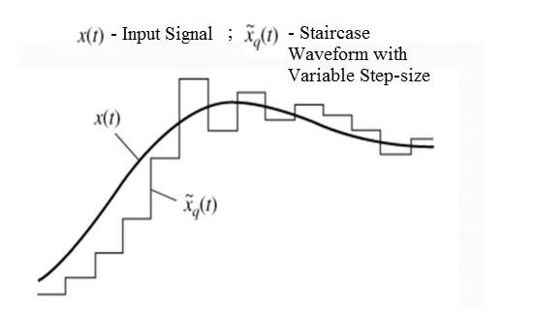

### Figure 2:adabtive Delta Modulation [3]

### 1.3 Applications[[edit](https://en.wikipedia.org/w/index.php?title=Delta_modulation&action=edit&section=7)]

Contemporary applications of delta modulation includes, but is not limited to, recreating legacy synthesizer waveforms. With the increasing availability of [FPGAs](https://en.wikipedia.org/wiki/FPGAs) and game-related [ASICs](https://en.wikipedia.org/wiki/ASICs), sample rates are easily controlled so as to avoid slope overload and granularity issues. For example, the [C64DTV](https://en.wikipedia.org/wiki/C64DTV) used a 32 MHz sample rate, providing ample dynamic range to recreate the [SID](https://en.wikipedia.org/wiki/MOS_Technology_6581) output to acceptable levels[1].[[8]](https://en.wikipedia.org/wiki/Delta_modulation#cite_note-8)

### Unipolar Return (RZ)and Non-return to zero(NRZ):

non-return-to-zero (NRZ) [line code](https://en.wikipedia.org/wiki/Line_code) is a [binary](https://en.wikipedia.org/wiki/Binary_coding) code in which ones are represented by one [significant condition](https://en.wikipedia.org/wiki/Significant_condition), usually a positive voltage, while zeros are represented by some other significant condition, usually a negative voltage, with no other neutral or rest condition.

For a given [data signaling rate](https://en.wikipedia.org/wiki/Data_signaling_rate), i.e., [bit rate](https://en.wikipedia.org/wiki/Bit_rate), the NRZ code requires only half the [baseband bandwidth](https://en.wikipedia.org/wiki/Bandwidth_(signal_processing)) required by the [Manchester code](https://en.wikipedia.org/wiki/Manchester_code) (the passband bandwidth is the same). The pulses in NRZ have more energy than a [return-to-zero](https://en.wikipedia.org/wiki/Return-to-zero) (RZ) code, which also has an additional rest state beside the conditions for ones and zeros.

When used to represent data in an [asynchronous communication](https://en.wikipedia.org/wiki/Asynchronous_communication) scheme, the absence of a neutral state requires other mechanisms for bit synchronization when a separate clock signal is not available. Since NRZ is not inherently a [self-clocking signal](https://en.wikipedia.org/wiki/Self-clocking_signal), some additional synchronization technique must be used for avoiding [bit slips](https://en.wikipedia.org/wiki/Bit_slip); examples of such techniques are a [run-length-limited](https://en.wikipedia.org/wiki/Run-length_limited) constraint and a parallel synchronization signal.[2]

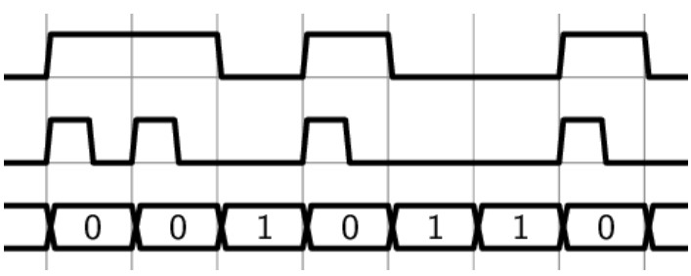

### Figure 3:Unipolar Return and non-return to zero [5]

When Mach Zehnder Modulator is Used: After the introduction of Mach Zehnder Modulator, distortion reduces significantly and data received at output is highly accurate.

This is because the data that is to be sent finds a carrier that helps in its transmission. So we find out that no matter which

modulation technique we use, if we don’t use a modulator, the data cannot be transmitted practically. Mach Zehnder Modulator

helps in transmitting the data to larger distance.

Looking at the Table 1, we find that when Mach Zehnder modulator is used both for RZ and NRZ, NRZ technique performs better

for the same other parameters. The reason for this is the more bandwidth required for the RZ technique that spreads the power more

than that in NRZ. As a result the spectral power in RZ is less than that of NRZ[9]

### 1.4 Slope Overload Distortion and Granular (Idle Noise), Quantization Noise in Delta Modulation

### Slope Overload Distortion and Granular (Idle Noise)

Slope overload distortion and granular (idle noise) are the two major drawbacks of delta modulation[4].  
So here we are going to discuss both of these drawbacks of delta modulation-  
Watch the Complete Video Here link - <https://youtu.be/m6_rAlsKKjQ?si=BIyjFSJDd-DC-Xnh> [4]

### 1.4.1 Granular noise:

This noise (error) occurs when the step size is too large in comparison to small variations in the input signal.  
So because of large step size in comparison to the signal having very small variations or constant; error is introduced between the input signal and the approximated staircases signal. This error is known as the granular or idle noise. [4]

### 1.4.2Solution of the Granular Noise (Idle Noise)

**We can overcome the problem of granular noise by keeping the step size small.**

### 1.4.2 Slope Overload Distortion

This distortion is caused due to large dynamic range of the input signal. Because When the input signal rising rate is very high, then the staircase signal cannot approximate it correctly.  
So it creates large error between the original input signal X(t) and the staircase approximated signal[4]. This noise (error) is known as slope overload distortion.

### 1.4.2.1Solution of Slope Overload Distortion

The step size must be increased, when the input signal has high Slope. Therefore we use Adaptive Delta Modulation technique where the step size is increased when large dynamic variations are present in the signal X(t), to reduce the quantization errors present in delta modulation[4].

_______________________________________________________________________

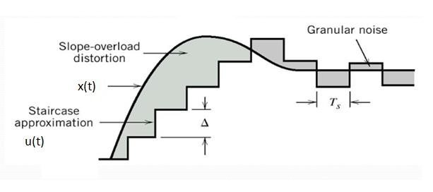

### Figure 4:Granular and slope overload noises [7]

As you can see in the image that the shaded part in red color shows the slope overload distortion present in Delta modulation while the shaded region in green color represents the granular noise which is also known as idle noise. Both of these errors (noises) are quantization errors and are present in Delta modulation[4].  
  
On observing this image carefully you will find that the area shaded in red colour is having large dynamic variations (steep slope) in the input signal, therefore the staircase waveform that is used to approximate this signal cannot approximate it. And the shaded region is the difference between the original signal and it's approximation. Here the small step size which is fixed step size (delta) of the staircase signal can not approximate it properly. So this slope overload distortion is due to large dynamic variations in the input signal[4].  
Now observe another part of this image which shows the granular noise[4].

-

### 3Procedure

### Part 1: Prediction signals in Linear delta modulation (LDM):

The objective of this part is to compare the original message signal with the predicted signal for

the Linear Delta Modulation.

In Part 1 of the experiment, the objective was to compare the original message signal with the predicted signal in Linear Delta Modulation (LDM). The procedure involved setting the clock frequency to 100 kHz, configuring the function generator to produce a 100 Hz sine wave with a 1 V peak-to-peak voltage, and adjusting the bridging plug to LDM at the input of integrating 2 using a wire. The CASSY Sensor UA1 was connected to the modulating signal S_m(t), while the CASSY Sensor UB1 was connected to the prediction signal X(t) at the output of (integrat 2). Measurements were started by pressing F9, and the clock frequency was gradually reduced to 10 kHz before repeating the measurements.

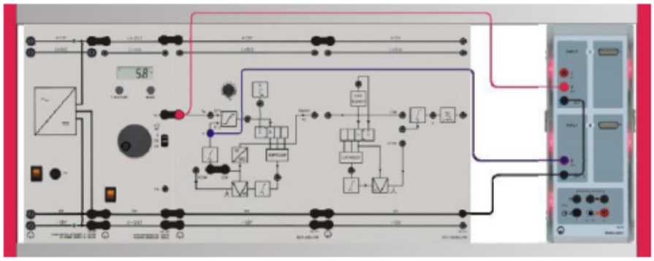

### Figure 5: LDM block diagram [8]

### Part 2: Prediction signals in Digital Controlled Delta Modulation (DCDM) :

In Part 2 of the experiment, the objective was to compare the original message signal with the predicted signal in Digital Controlled Delta Modulation (DCDM). The procedure involved using the same setup as in Part 1, but with the bridging plug adjusted to DCDM at the input of ∫2. The measurements were then repeated following the same steps as those conducted in Part 1.

In this part Fclk =50KHz and sin wave with fm=100Hz

### Part 3: Pulse height in LDM:

In Part 3 of the experiment, the goal was to investigate pulse height in Linear Delta Modulation (LDM). The procedure involved setting the clock frequency to approximately 50 kHz, adjusting the function generator to output a 100 Hz sine wave with a 1 V peak-to-peak voltage, and configuring the bridging plug to LDM at the input of ∫2. To accurately measure the delta (increment/decrement) contributing to X(t) during each clock period, the input of the accumulating integrator was measured at ∫2 to observe the pulse amplitude. The CASSY Sensor UA1 was connected to the modulating signal Sm​(t), and CASSY Sensor UB1 was connected to the LDM signal at the input of ∫2. Measurements were started by pressing F9, and the peak-to-peak voltage VSS​ was gradually increased in 1 V steps up to 7 V. The effects of increasing VSS​ on the output of the LDM were then analyzed. Following this, CASSY Sensor UB1 was reconnected to the prediction signal X(t) at the output of ∫2, and the effects of increasing VSS​ on the predicted signal were examined. Finally, these measurements were appended to the previous data for comprehensive analysis, the connections explain as shown figure10 .

### 

### Figure 6:Pulse height in LDM block diagram [8]

### Part 4: Pulse height in DCDM:

In Part 4 of the experiment, the objective was to examine pulse height in Digital Controlled Delta Modulation (DCDM). Using the same setup from Part 3, the bridging plug was adjusted to DCDM at the input of ∫2. The measurements were then repeated as conducted in Part 3. It was investigated whether the pulse height was dependent on or independent of Sm​(t), and the relationship between the pulse height of the DCDM output at the input of ∫2 and the amplitude of Sm​(t) was analyzed.So in this part is the same setup of the previous one(Fclk =50KHz and sin wave with fm=100Hz) but

### Part 5: Output signals of the LDM modulator (RZ/NRZ):

In Part 5 of the experiment, the objective was to identify the types of signals used to represent the modulated delta signal and the feedback signal for prediction in Linear Delta Modulation (LDM). The procedure involved setting the clock frequency to 10 kHz and configuring the function generator to output a 100 Hz sine wave with a 1 V peak-to-peak voltage. The bridging plug was set to LDM at the input of ∫2. The CASSY Sensor UA1 was connected to the LDM signal at the input of ∫2, while the CASSY Sensor UB1 was connected to the DM signal at the output of the DM modulator, specifically to capture the bipolar Return to Zero (RZ) signal. The measurement was then started by pressing F9.So in this part the Fclk=10KHz and sine wave with fm=100hz and Vss=1v

### 

### Figure 7: LDM modulator (RZ/NRZ)block diagram

### Part 6: Granular noise in LDM

To investigate granular noise in Linear Delta Modulation (LDM), the components were assembled as follows: the clock frequency f Clock​ was set to 10 kHz, and the function generator was configured to output a pulse train with a frequency f_M​ of 200 Hz, amplitude VSS​ of 2 V, and a duty cycle d% of 50%. The bridging plug was set to LDM at the integrator input, and CASSY Sensor UA1 was connected to the modulating signal Sm​(t) while CASSY Sensor UB1 was connected to the prediction signal X(t) at the integrator output. Measurement was initiated by pressing F9, and the experiment was repeated with the clock frequency set to 100 kHz. Subsequently, the bridging plug was removed, and the input of the delta modulator was connected to ground as shown bellow figure. Measurements were then repeated for both clock frequencies of 10 kHz and 100 kHz to assess the impact on granular noise.

### 

### Figure 8: Granular noise in LDM block diagram

### Part 7: Granular noise in DCDM

For Part 7, to investigate granular noise in Delta-Coded Delta Modulation (DCDM), the following steps were performed: The setup used in Part 6 was retained. The clock frequency Clock​ was set to 10 kHz, and the function generator was configured to output a pulse train with a frequency fM​ of 200 Hz, amplitude VSS​ of 2 V, and a duty cycle d% of 50%. The bridging plug was then set to DCDM at the input of the integrator ∫2. All measurements were repeated as conducted in Part 6 to assess granular noise in DCDM under these conditions.

### Part 8: Slope-overload in LDM

To carry out this experiment, assemble the components as shown below.

### 

### Figure 9: Slope-overload in LDM block diagram

To investigate slope-overload in Linear Delta Modulation (LDM), the following procedure was carried out: The clock frequency Clock​ was set to 100 kHz, and the function generator was initially configured to output a sine wave with a frequency fm​ of 100 Hz and an amplitude VSS​ of 4 V. The bridging plug was set to LDM at the integrator input ∫2. CASSY Sensor UA1 was connected to the modulating signal Sm​(t), and CASSY Sensor UB1 was connected to the prediction signal X(t) at the integrator output. Measurement was started by pressing F9. Next, the function generator was changed to output a pulse train with fm​ of 100 Hz, VSS​ of 4 V, and a duty cycle d% of 50%, and the measurement was repeated. Finally, the function generator was set to a pulse train with fm​ of 300 Hz, VSS​ of 4 V, and d% of 50%, and the measurement was repeated again to assess the impact of different modulation frequencies on slope-overload.

### Part 9: Slope overload in DCDM

To investigate slope-overload in Delta-Coded Delta Modulation (DCDM), the following steps were followed: The setup from Part 8 was retained, with the modification of increasing the function generator’s amplitude VSS​ to 9 V. The bridging plug was adjusted to DCDM at the integrator input ∫2. All measurements were then repeated as conducted in Part 8, which included setting the function generator to output a sine wave at 100 Hz, then a pulse train at 100 Hz, and finally a pulse train at 300 Hz, each time recording the impact on slope-overload with the updated voltage setting.

### Part 10: Dynamic of LDM and DCDM

### 10.1 Dynamic of LDM

To assess the dynamics of Linear Delta Modulation (LDM) and Delta-Coded Delta Modulation (DCDM), the setup for LDM was configured with a clock frequency of 100 kHz and a sine wave input at 100 Hz with an initial amplitude of 1 V. The bridging plug was set to LDM at the integrator input, and CASSY Sensors UA1 and UB1 were connected to measure the modulating and prediction signals, respectively. Measurements were started by pressing F9, and the amplitude VSS​ was gradually increased until the prediction signal X(t) began to show slope overload, recording this maximum voltage as Amax ​ in Table 1. This process was repeated for sine wave frequencies of 200 Hz, 300 Hz, 400 Hz, 500 Hz, 1000 Hz, 1500 Hz, and 2000 Hz. Finally, the dynamic range D was calculated.

### 

### Figure10: Dynamic of LDM and DCDM

### 10.2 Dynamic of DCDM

To investigate the dynamics of Delta-Coded Delta Modulation (DCDM), follow these steps: First, change the bridging plug to DCDM at the input of ∫2. Reduce the function generator's amplitude VSS​ to 1 V. Gradually increase VSS​ until the prediction signal X(t) starts to exhibit slope overload, and record this maximum value as Amax​ in Table 2. Repeat this process for signal frequencies of 200 Hz, 300 Hz, 400 Hz, 500 Hz, 1000 Hz, 2000 Hz, and 3000 Hz.

### Results and Discussion

### Part 1: Prediction signals in Linear delta modulation (LDM):

5.1.1Set the Clock frequency fClock = 100 kHz (max)



### Figure11: Set the Clock frequency fClock = 100 kHz (max)

Set the function generator to: Sine, fm = 100 Hz, VSS = 1 V



### Figure12: Set the function generator to: Sine, fm = 100 Hz, VSS = 1 V

### 4.1.1result of part 1 in time domain

In this part, we compared the original message signal with the predicted signal in Linear Delta Modulation (LDM). We observed that as the clock frequency was reduced from 100 kHz to 10 kHz, the accuracy of the prediction decreased. At higher frequencies, the predicted signal closely followed the original signal, but as the frequency decreased, discrepancies became more apparent. This behavior is due to the fixed step size in LDM, which can lead to poor signal tracking and increased distortion when the clock freque ncy is lower.

### Figure 13:LDM modulated signal when Fclk=100KHz in time domain

### In this figure the clock freq was the max (100KHz) and the black wave represent the original signal and the red one is the predicted .The figure below show the signal when the clock freq was reduced to the min value (10KHz):

### Figure 14:LDM modulated signal when Fclk=10KHz

As the previous figures show when Fclk was in the max value the prediction signal nearly equal

the original one but when Fclk was in the min value the prediction went a way from the original

### Part 2: Prediction signals in Digital Controlled Delta Modulation (DCDM) :

The objective of this part is to compare the original message signal with the predicted signal for

the Digital Controlled Delta Modulator. This part is the same steps of the previous part put here

the bridging plug is setting to DCDM (at the input of ∫2) . The adaptive step size in DCDM allowed for better adjustment to the signal's variations, resulting in a closer match between the predicted and original signals. This improvement indicates that DCDM handles rapid changes in the signal more effectively than LDM, reducing distortion and enhancing signal fidelity.

The figure below at max Fclk=100KH : 

### Figure15: DCDM modulated signal at max fclk

At min Fclk = 10KH:



### Figure 16: DCDM modulated signal at min fclk

As the previous figures show when Fclk was in the max value the prediction signal nearly equal the original one but when Fclk was in the min value the prediction went a way from the original

### Part 5: Output signals of the LDM modulator (RZ/NRZ):

The objective of this part is to find the type of signals used to represent the modulated delta signal and the signal used in the feedback path to generate the prediction.

### 

### Figure 17: Output signals of the LDM modulator (RZ/NRZ)

This figure shows the black wave (origine ) is Bi bolar non return to zero and the Red

one(prediction) is Bi bolar return to zero.

### Part 6: Granular noise in LDM:

In this part Fclk will be changed 2times and the message set Pulse train,with fm= 200 Hz, VSS

2 V, d% = 50

*When fClock = 10 kHz (min) and the bridging plug to LDM (at the input of ∫2).

### 

### Figure 18: Granular noise in LDM at the input of ∫2 , when fm=10k

*When fClock = 100 kHz (max) and the bridging plug to LDM (at the input of ∫2).:



### Figure 19: Granular noise in LDM at the input of ∫2 , when fm=100k

From the previous figures notice that when Fclk =100khz (max) the granular noise get smaller and the prediction nearly close to the origin but when fclk =10khz the granular will be grater so when fclk getting big the granular noise will be smaller .

**\*\*When the bridging plug between the function generator and the input of the delta modulator removed . And Connected the input of the delta modulator to ground:**



### Figure 20: Granular noise in LDM when bridging plug removed at fm=10khz



### Figure 21: Granular noise in LDM when bridging plug removed at fm=100khz

From the previous figures note that after removing the bridging plug when Fclk =100khz the noise approximate to zero that mean the prediction signal will applay to origin signal .

### Part 7: Granular noise in DCDM:

This part has the same setup of the previous part but here Set the Clock frequency fClock = 10 kHz (min) and the function generator to Pulse train with fm= 200 Hz, VSS = 2 Vand d% = 50 and Set the bridging plug to DCDM (at the input of ∫ 2)



### Figure 22: Granular noise inDCDM fm=10khz



### Figure 23: Granular noise inDCDM fm=100khz

### Part 8: Slope overload in LDM:

When Fclk=100khz and the function generator is set to Sine, fm = 100 Hz, VSS = 4 V:



### 24: Slope overload in LDM when function genarator is sin

*When Fclk=100khz and the function generator is set to Pulse train, fm = 100 Hz, VSS = 4 V,

d% = 50:



### Figure 25: Slope-overload in LDM when function genarator is pulse with fm=100hz

*When Fclk=100khz and the function generator is set to Pulse train, fm = 300 Hz, VSS = 4 V, d% = 50: 

### Figure 26: Slope-overload in LDM when function genarator is pulse with fm=300hz

The previous figures show the smallest overload noise appeare when function generator is set to Sine . also , slope over load increase when the signal slope exceeds the modulation capability. In this part of the experiment, the goal was to evaluate the performance of Linear Delta Modulation (LDM) with varying input signals. The setup began with setting the clock frequency fClock to its maximum of 100 kHz. The function generator was initially configured to produce a sine wave with a frequency of 100 Hz and an amplitude of 4 V. The bridging plug was set to LDM, and the CASSY Sensors were connected to measure the modulating signal S_m(t) and the prediction signal X(t) . Measurements were taken by pressing F9 to capture the data. Subsequently, the function generator was switched to a pulse train with a frequency of 100 Hz, an amplitude of 4 V, and a duty cycle of 50%, and the measurement was repeated. This process was further repeated with the pulse train frequency increased to 300 Hz, maintaining the same amplitude and duty cycle. This series of measurements aimed to analyze how LDM handles different types of input signals and frequencies, providing insights into its performance and response characteristics.

### Part 9: Slope overload in DCDM:

This part has the same set up but here Vss increased to 9V. And Set the bridging plug to DCDM (at the input of ∫ 2).

When the function generator set to Sine with fm = 100 Hz

each with a 50% duty cycle. By maintaining the same measurement procedure, the experiment aimed to compare the performance of DCDM against LDM, particularly observing any differences in signal handling, distortion, and overall modulation quality between the two methods.



### Figure 27: Slope overload in DCDM when function generator is sin



### Figure 28: Slope-overload in DCDM when function generator is pulse with fm=100hz

So now when the function generator is set to pulse with fm = 300 Hz the result will be as show bellow the Slope-overload in DCDM when function generator is pulse with fm=300hz is appear in bellow figure :



### Figure 29: Slope-overload in DCDM when function generator is pulse with fm=300hz

### Part 10: Dynamic of LDM and DCDM:

In this part, the maximum value of the input voltage (for a given frequency)will be determinde below which slope overload can be avoided for the LDM.

*When the Clock frequency fClock = 100 kHz (max) and the function generator is set to: Sine with fm = 100 Hz, VSS = 1 V. and Set the bridging plug to LDM (at the input of ∫2):



### Figure 30:Dynamic of LDM and DCDM with fm=100hz and Vss=1v

*When VSS changed until the prediction signal X(t) shows the beginning of the slope overload.

This value is denoted as 𝑨𝒎𝒂𝒙 :

In this Part of the experiment, the objective was to determine the maximum input voltage Amax for Linear Delta Modulation (LDM) at various frequencies while avoiding slope overload. By setting the clock frequency to 100 kHz and the function generator to a sine wave with an initial amplitude of 1 V and a frequency of 100 Hz, the setup was configured to measure the modulating signal and the prediction signal. As VSS was adjusted, the point at which the prediction signal X(t) began to exhibit slope overload was recorded as A{max). This process was repeated for modulating signal frequencies of 200 Hz, 300 Hz, 100 Hz, 500 Hz, and 1000 Hz,, . The resulting values of A_text{max} at each frequency were then used to calculate the dynamic range ( D ), providing insight into how the LDM system's performance varies with different signal frequencies and amplitudes. This analysis is crucial for understanding the limits of LDM in handling varying input amplitudes without introducing distortion or error due to slope overload.



### Figure 31:Dynamic of LDM and DCDM with fm=100hz and Vss=2.9(max)

This figure shows when Vss was changed until arraive the case when the prediction signal applay to origin signal and as a result of that Vss stop at 2.9V

The table below shows the relation between the dynamic range and the frequency of the message signal:

|  |  |  |
| --- | --- | --- |
| Frequency HZ | Amax for LDM | D of LDM |
| 100 | 2.9 | 43.20 dB |
| 300 | 1.7 | **38.56 dB**. |
| 500 | 1.2 | 35.56 dB |
| 1000 | 0.7 | 30.92 dB |

### Table 1. Dynamic of LDM

To calculate the dynamic D :

D=20 log(

Amax/Amin) dB 0.1 (assume Amin= 20m Vpp)

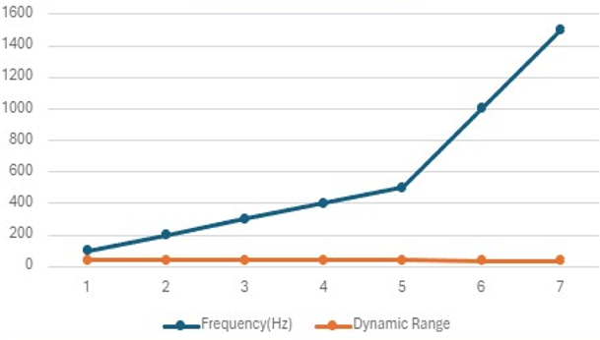

*This figure shows when the freq increased then dynamic rang will decrease

* When Change the bridging plug to DCDM (at the input of ∫2). And Reduce Vss to 1V:

|  |  |  |
| --- | --- | --- |
| Frequency HZ | Amax for LDM | D value ≈ |
| 100 | 16.5 | 58.32 dB |
| 300 | 8.8 | 52.86 dB |
| 500 | 5.8 | 49.24 dB |
| 1000 | 3 | 43.52 dB |

### Table 2. Dynamic of DCDM



### Part 11:

### Demodulation (LDM/DCDM):

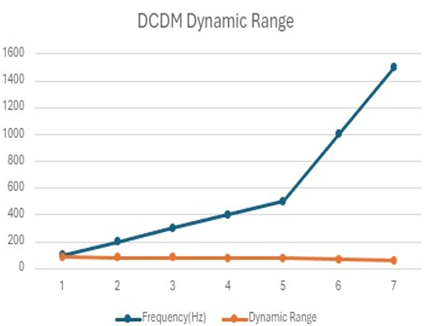



### .Demodulation for LDM

**1**

*When

the Clock frequency fClock = 100 kHz (max) and

the function generator is set to: Sine,

fm = 100 Hz, VSS = 4 V. and the bridging plug to LDM (at the input of ∫2).

### Figure 32:LDM Demodulation when sine generator with fm=100hz



**\***

when

function generator is set to: Pulse train, with fm=100Hz, VSS=4 and d=50%.

### Figure 33:LDM Demodulation when pulse generator with fm=100hz



when function generator is set to: Pulse train, with fm=300Hz, VSS=4 and d=50%.:

### Figure34LDM Demodulation when pulse generator with fm=300hz



### .Demodulation for

**2**

### DCDM

*When

the Clock frequency fClock = 100 kHz (max) and the function generator is set to: Sine,

fm = 100 Hz, VSS = 4 V.

### Figure 35:DCMD Demodulation when sine generator with

### fm=100hz

**\***



when function generator is set to: Pulse train, with fm=100Hz, VSS=4 and d=50%.:

### Figure 36:DCMD Demodulation when pulse generator with fm=100hz

In this experiment, you evaluated the performance of Linear Delta Modulation (LDM) and Differential Delta Modulation (DCDM) by examining their response to different signal types and frequencies. For LDM, you initially set the clock frequency to 100 kHz and used a sine wave from the function generator with a frequency of 100 Hz and an amplitude of 4 V. After configuring the setup with the LDM bridging plug, you connected the CASSY Sensors to measure the modulating signal and the demodulated signal, recording data for the sine wave. Then, you switched the function generator to a pulse train with a frequency of 100 Hz and a 50% duty cycle, repeating the measurements. This was followed by increasing the pulse train frequency to 300 Hz to better observe demodulation distortion. For DCDM, the same procedure was followed, but with the bridging plug set to DCDM, to compare the performance and distortion characteristics between LDM and DCDM under identical conditions. This approach allowed for a comprehensive comparison of the modulation and demodulation capabilities of both systems.

### Conclusion:

In Conclusion, this experement manage to know how can the analog signales convertor to digital ones by using a special type of uniform quantizer (delta modulation ) and how can these signals will be encoded to zeros and ones by using different types of encoding . Also it manages to deal with two types of noises which will apeare where granular or overload .

### Refrences:

[1] [Delta modulation - Wikipedia](https://en.wikipedia.org/wiki/Delta_modulation) 10-8-2024 at 5:45 AM

[2] [Non-return-to-zero - Wikipedia](https://en.wikipedia.org/wiki/Non-return-to-zero) 10-8-2024 **at 5:49AM**

[3]https://www.elprocus.com/adaptive-delta-modulation-block-diagram-and-applications/ **Thursday at 1:53am**

[4] [Engineering Made Easy: Slope Overload Distortion and Granular (Idle Noise), Quantization Noise in Delta Modulation (engineeringmadeeasypro.com)](https://www.engineeringmadeeasypro.com/2018/06/Slope-Overload-Distortion-and-Granular-Noise-Quantization-Noise-in-Delta-Modulation.html) **at 6:14AM**

[5]https://www.researchgate.net/figure/A-comparison-between-the-Non-Return-to-Zero-NRZand-Return-to-Zero-RZ-On-Off-Line_fig6_307984756 **Thursday at 2:16am**

[6]https://testbook.com/question-answer/in-a-delta-modulation-system-the-granular-noise-i-601b6efefe1f1cb4f9761f66 **Thursday at 2:32am**

[7]https://electronicspost.com/what-is-slope-overload-distortion-and-granular-noise-in-deltamodulation-and-how-it-is-removed-in-adm/ **Thursday at 2:38am**

[8]lab manual

[9] [Comparison of RZ and NRZ Modulation Techniques by Varying Duty Cycle and Mach Zehnder Modulator | sehrish shabir - Academia.edu](https://www.academia.edu/102682038/Comparison_of_RZ_and_NRZ_Modulation_Techniques_by_Varying_Duty_Cycle_and_Mach_Zehnder_Modulator) **Mondy at 2:38am**